Volume 1 Number 12 11th May 2018

Nóta ón bPríomhoide:

A Chairde,

Welcome to “An Nasc” number 12. Senior students are kindly asked to take note of the important information in the ‘Careers’ Corner’.

Le gach dea-ghuí

S. Ó Murchú
Principal

*********************
In this edition:
Nóta ón bPríomhoide Page 1
An tSeachtain Seo Chugainn Page 2
Careers’ Corner Page 2
Well-Being Health Initiative Page 3/4
Student Enterprise Awards Page 4
Transition Year News Page 5
Parents’ Association Page 6
Contact Details Page 6

An tSeachtain Seo Chugainn…
(Next Week …)
Mon. May. 14th |  | TY Heaney & Joyce Driving School
Tues. May. 15th | 19:00 | TY Beckett & Yeats Driving School  Annual Award Ceremony – Br. Donovan Hall
Wed. May. 16th |  | TY Heaney 7 Joyce Fire Safety
Thurs. May. 17th | 19:00 | TY Beckett & Yeats Fire Safety  Information Meeting for in-coming  1st Year Parents – Assembly Hall
Fri. May. 18th |  | TY Interschool’s Bridge Competition

*********************
Careers’ Corner
Please be advised that the 'Change of Mind Option' is currently open for any C.A.O. applicant who wishes to change their course preferences or add on additional choices. It is advised that all students would fill in a number of options for Levels 6, 7 and 8.

Please check https://www.cao.ie/handbook.php?page=changes to see changes which the C.A.O. and colleges have introduced to certain courses on offer.

Fifth Year students who completed their "CAT 4 "Aptitude Examination, are asked to make an appointment with the Guidance Counsellor to discuss their results.

I.T. Tallaght are running a Free Summer Camp (two days) for students from Third to Sixth Year who 'have experience with code or in a coder dojo, with any experience from Scratch to Javascript'. Please see https://www.eventbrite.ie/e/summer-camp-session-2-python-and-more-tickets-45909011088 .
Be advised that tickets to their other camps have booked out quickly and it is expected that this camp will book out quickly also.

The National College of Art and Design are offering free places on their Enterprise camps this Summer. According to the information provided on their website, these camps "Explore Sustainability, Entrepreneurship, Creativity, Innovation, Design Thinking and Design Strategies; Product based business and /or Service based business." Please see http://www.ncad.ie/study-at-ncad/ncad-youth-art-programme/#CESC for further information. Be advised that these particular camps are not Art Camps.
[Ms. Ruane]

6th Year - “Well-Being” Initiative

This month, a National Campaign by ‘See Change’ is encouraging everyone to break down the stigma surrounding us speaking about our Mental Health. In support of this campaign, our school organized a Well-Being ‘get-together’ for our 6th years to make them aware of the cause. Information was distributed during a short presentation and time was given to the pupils to engage with the topic via leaflets and conversation. The 6th years were offered and wore a Green Ribbon in support of the campaign. They have proven to be great leaders and representatives of our school for the younger year groups to look up to when it comes to helping end this stigma. Well done to them and best wishes for the coming weeks ahead. #GreenRibbonIrl

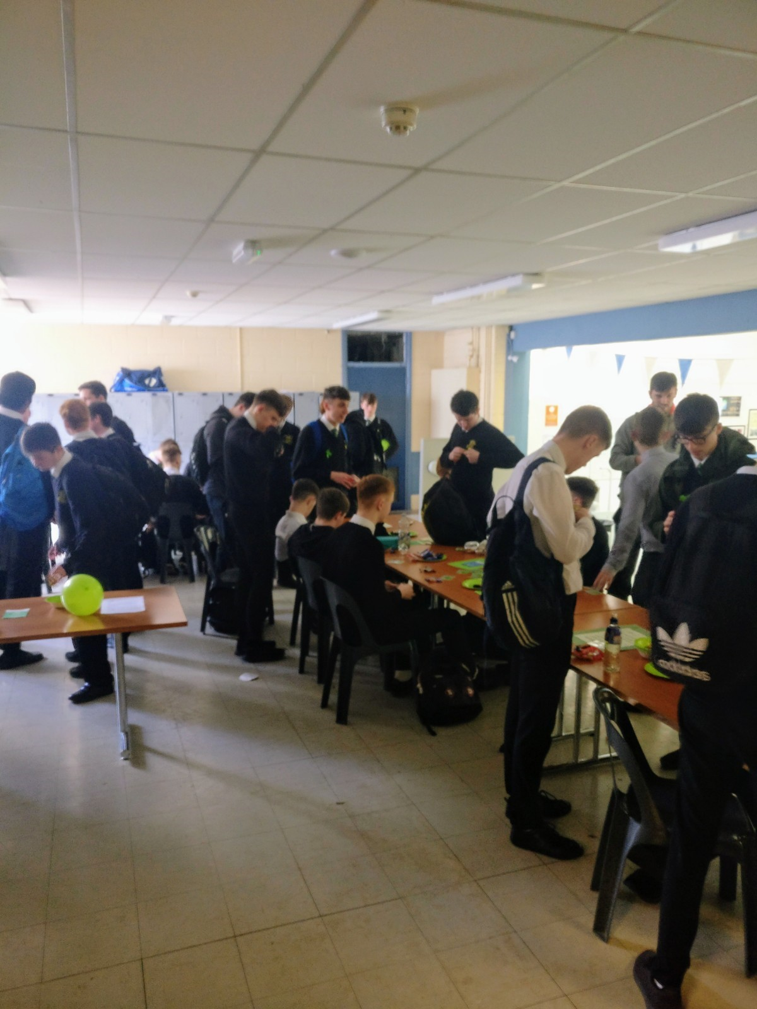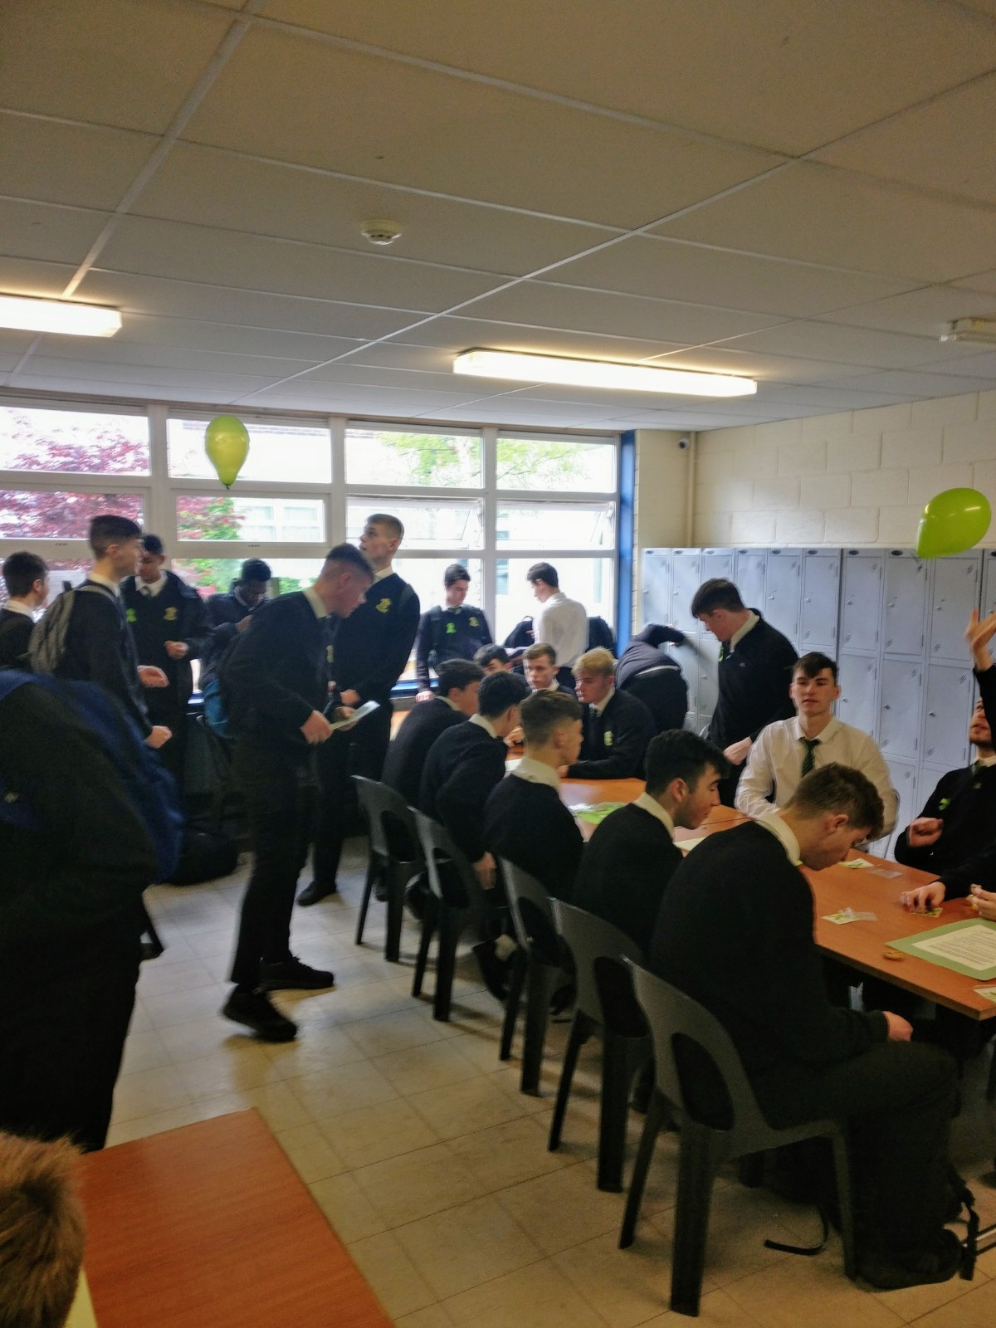

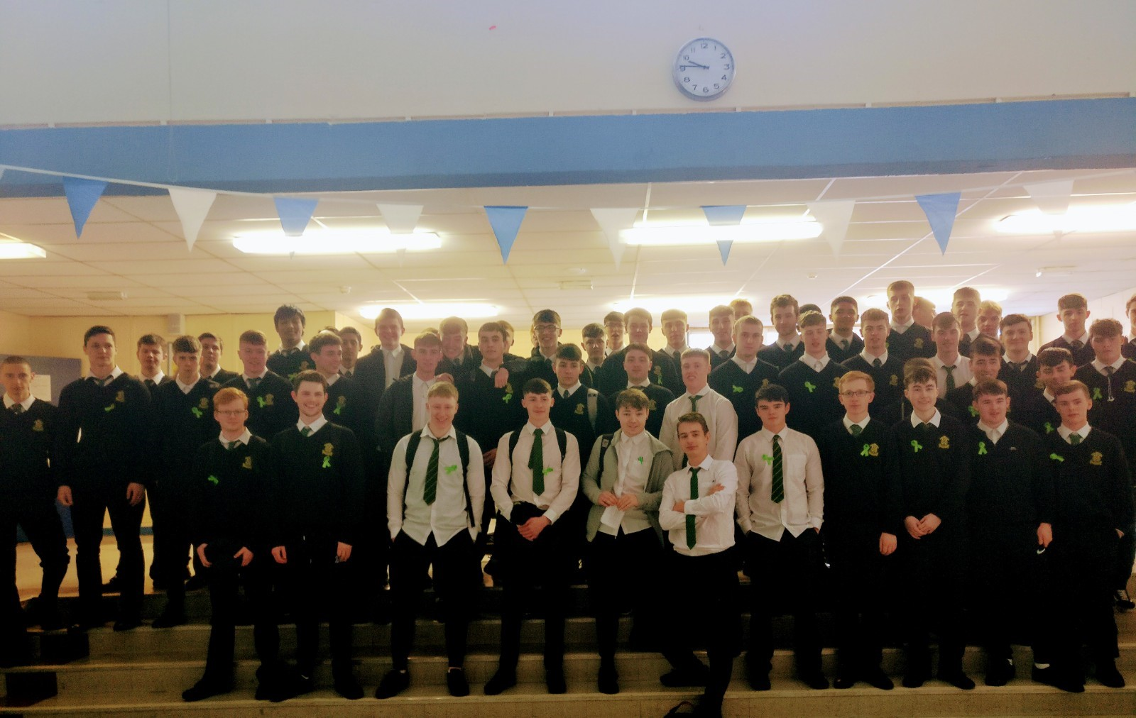
[Ms. Conroy]

*********************
Student Enterprise Awards

Fionn McBride (TYH), Rory Duggan (TYH) and Colm Ward (A4) represented the school in the All Ireland Finals of the Student Enterprise Ireland Awards on Wednesday 2 May 2018. Unfortunately, the boys didn’t win anything on the day, however they were a credit to the school in terms of how they carried themselves and represented the school at the awards.

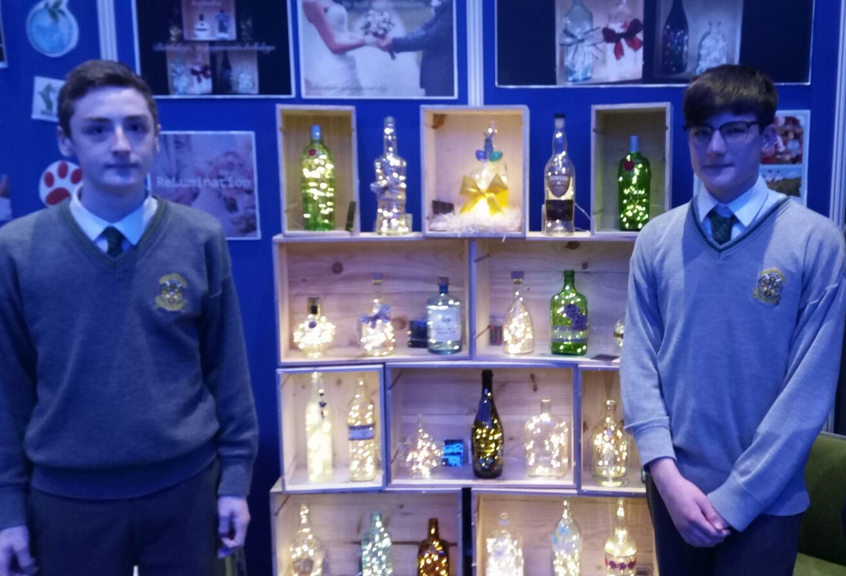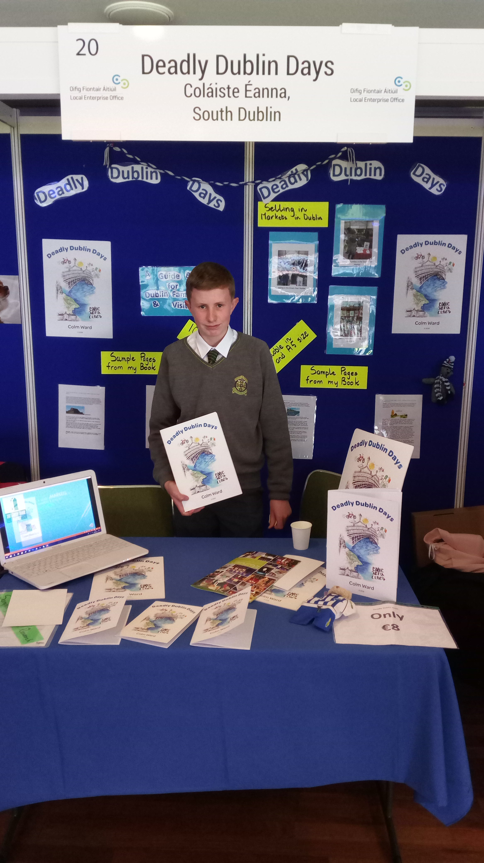

[Mr. Murray]

*********************
Transition Year News

Gaisce Hike:

Well done to the 26 TY students who completed their 27km Gaisce hike this week. The hike took place over 2 days, Tuesday and Wednesday, and was a great success. Thanks to Mr. Furlong who led the group, as well as Mr. Quinn and Dermot Daly who looked after them all on the trip.

Upcoming events next week:

Driving School:

Monday - (TY Heaney and TY Joyce)
Tuesday - (TY Beckett and TY Yeats)

Fire Safety Workshops:

Wednesday 8.45am – TY Heaney
Wednesday 11am – TY Yeats
Thursday 8.45am – TY Beckett
Thursday 11am – TY Joyce

Inter Schools Bridge Competition:

Friday 10am – 2.15pm approx
Students to all meet in the Templeogue Bridge Centre
(Located opposite Cheeverstown House, beside St. Michaels House)
Students should bring their own lunch as there will be a break but they may not leave the premises

End of Year Portfolio Interviews:

All TY students will have their end of year interview next week. Timetable issued to students and also posted on noticeboard in ERST Building.
Students should have their various completed projects from the year in their portfolio/folder on the day.

[Mr. Conway]

*********************
Parents’ Association

The winners of the monthly draw for May were as follows:

1st prize (€250) Mr. McDermott
2nd prize (€100) Eamonn Connolly
3rd prize (€50) Jerry Corcoran

Next meeting: Tuesday 4th September 2018 at 19:30 in room 37/38 ERST Building
AGM: Tuesday 11th September 2018
[Parents’ Association]

Contact Details
Coláiste Éanna C.B.S., Hillside Park, Ballyroan Road, Rathfarnham, Dublin 16. D16 248
Phone: 01-4931767
Email: secretary@colaisteeanna.ie

